TERRAFORM TASK-2
Execute all the templates shown in the video.
Integrate Terraform in Jenkins using the Terraform
plugin.
Terraform Hands-on — Short Steps
1. Create directory
mkdir terraform-provider
cd terraform-provider
2. Create local.tf
resource "local_file" "pet" {
filename = "pets.txt"
content = "we love pets!"
}
3. Run commands
terraform init
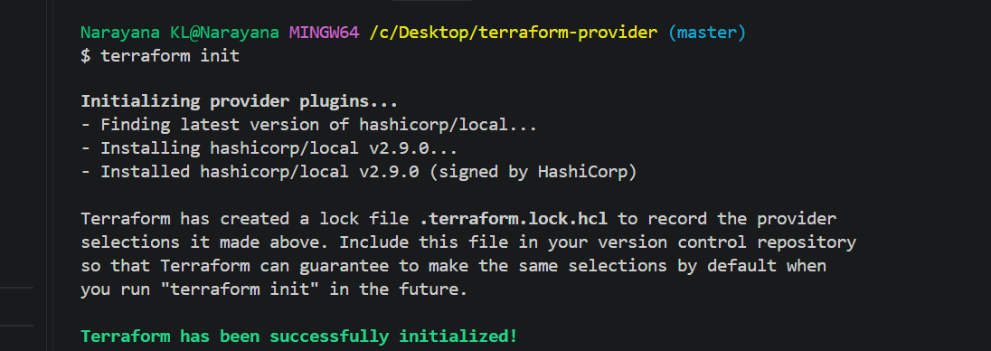
terraform validate
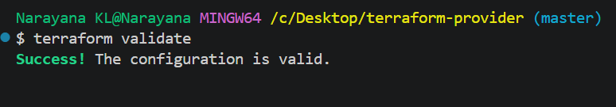
terraform fmt
terraform plan
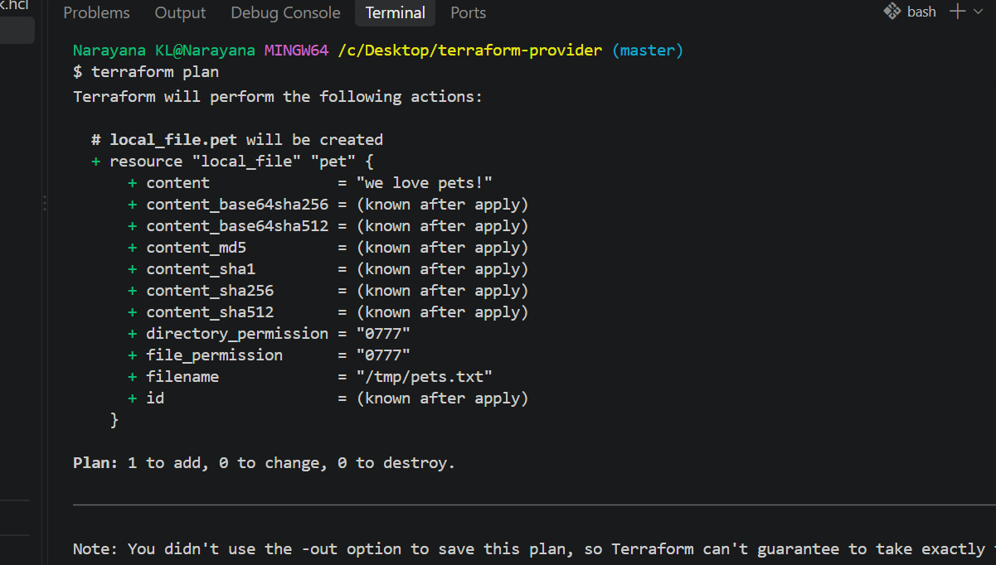
terraform apply
Type yes.
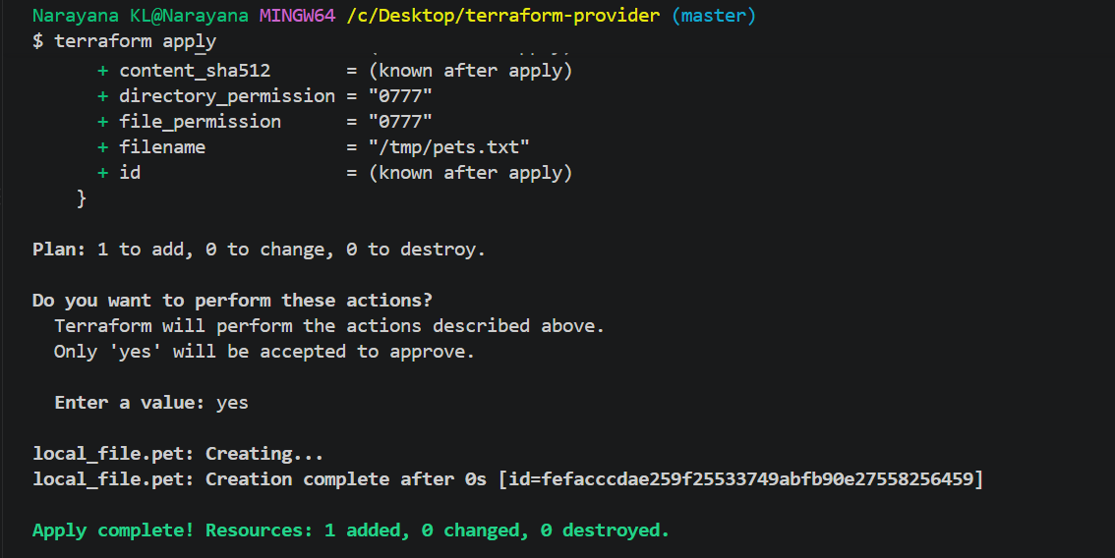
4. Verify
cat pets.txt
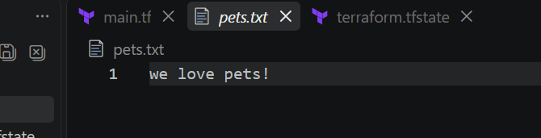
terraform show
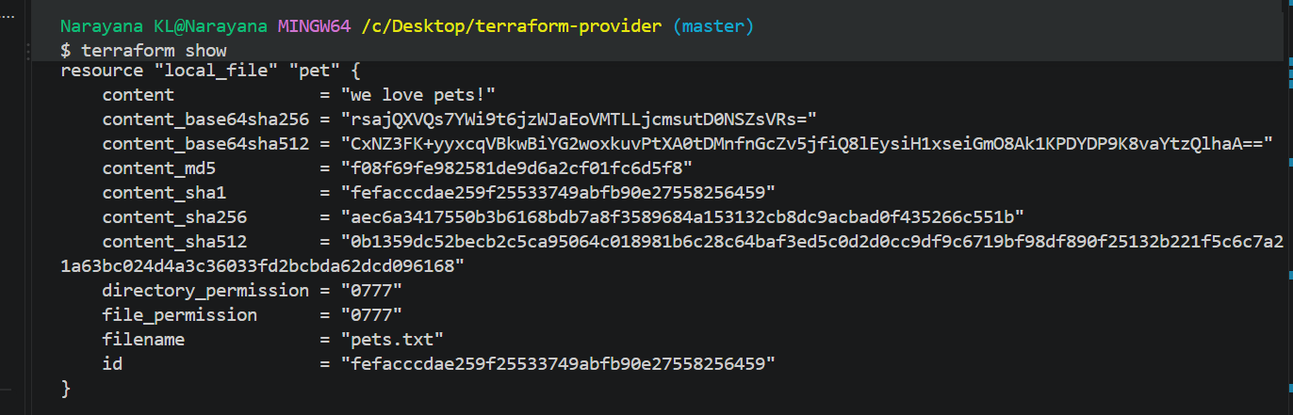
terraform state list
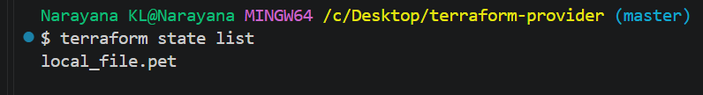
5. Delete
terraform destroy
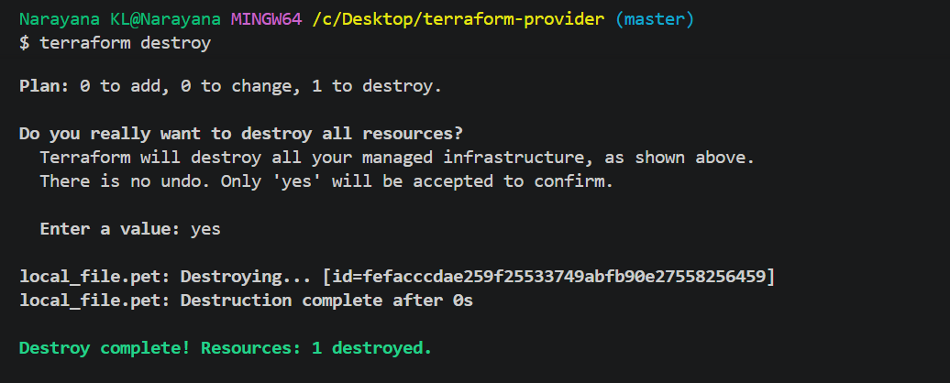
Next Topics
Do each topic separately:
6. Multiple Providers
resource "random_pet" "mypet" {
prefix = "MR"
separator = "."
length = 1
}
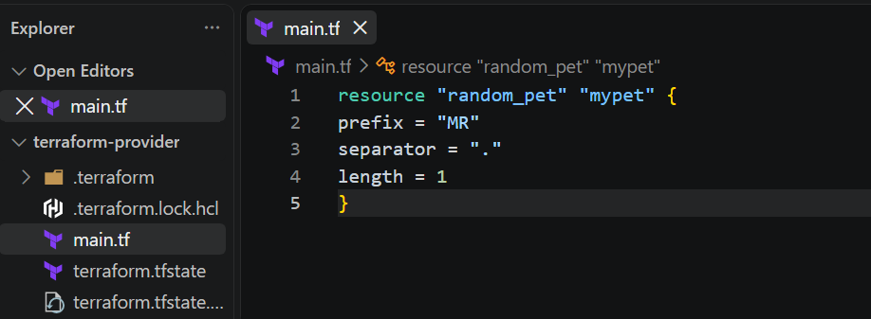
terraform init
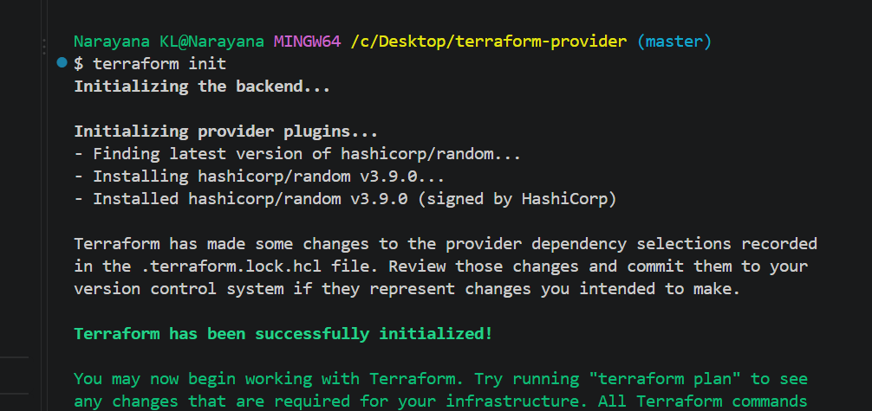
terraform apply
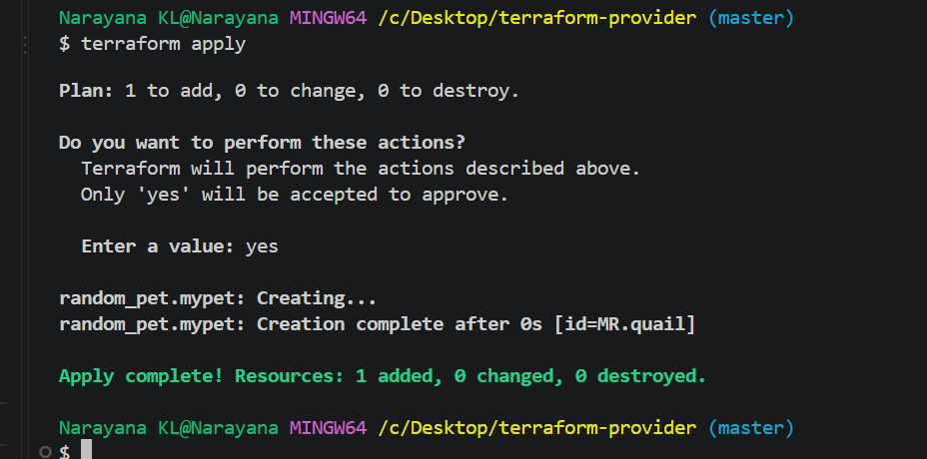
7. Variables
Create: variables.tf
variable "filename" {
type = string
default = "/tmp/pets.txt"
}
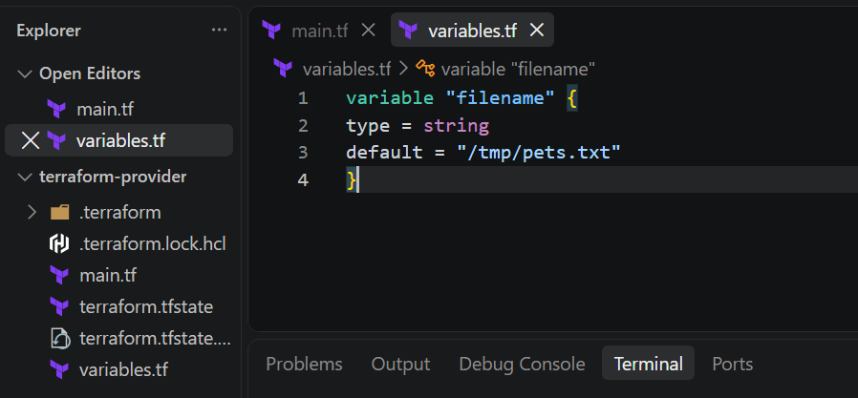
Use:
filename = var.filename
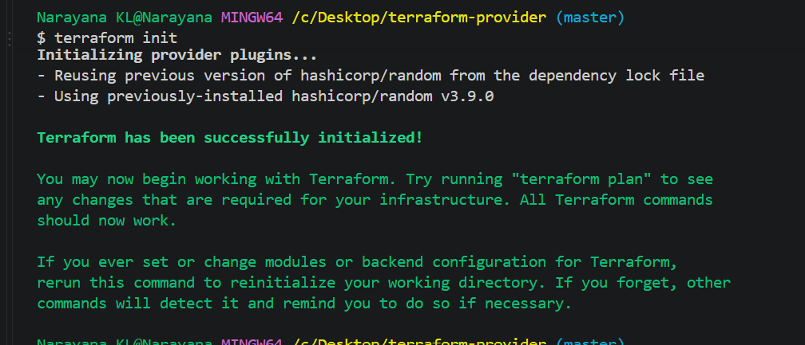
terraform fmt
terraform validate
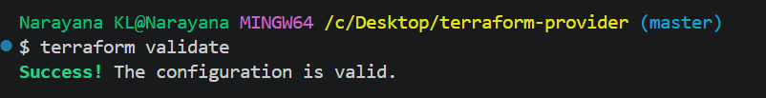
terraform plan
terraform apply
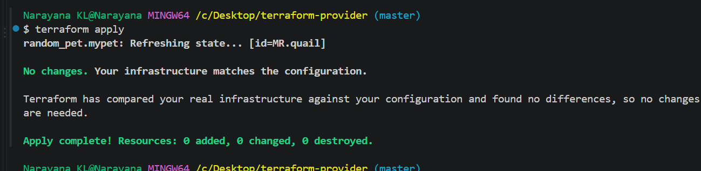
8. Attribute Reference
content = "My pet is ${random_pet.mypet.id}"
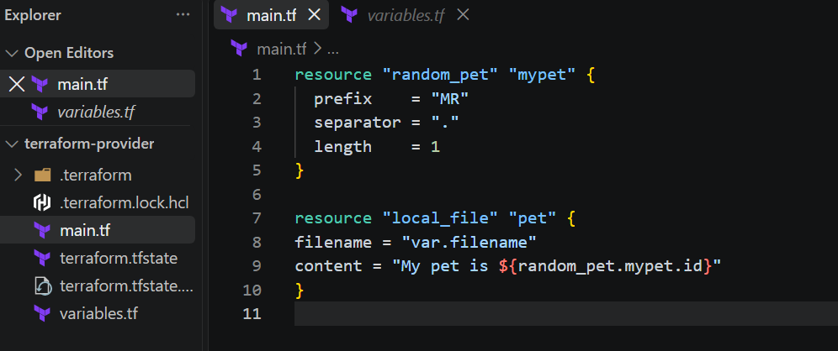
Step 2: Initialize
terraform init
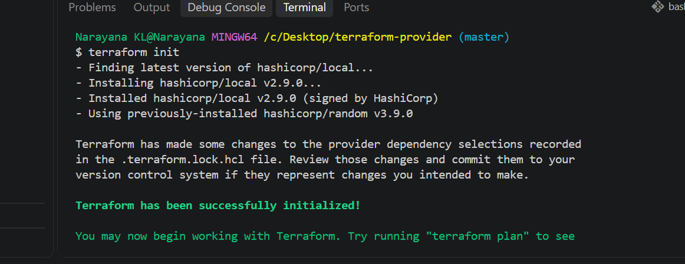

Step 3: Apply
terraform plan
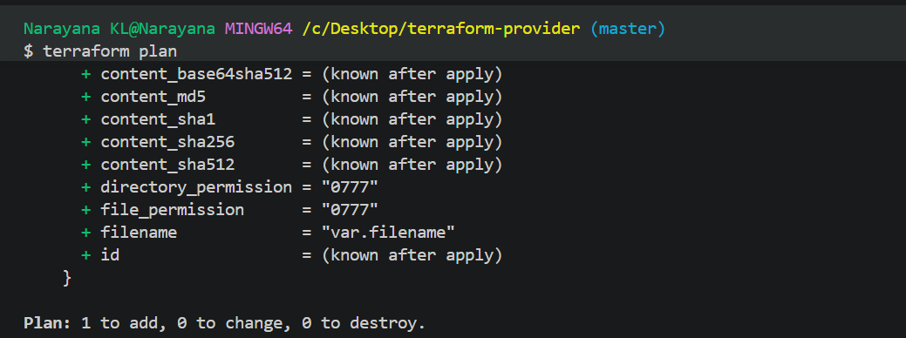
terraform apply
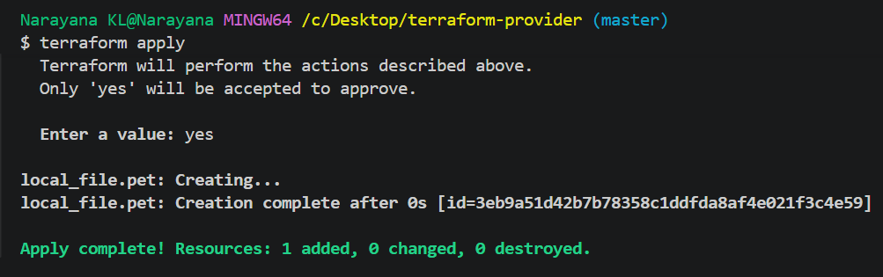
Step 4: Check
cat pets.txt
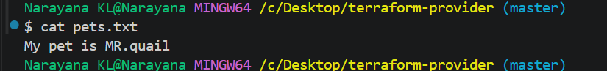
9. Dependency
depends_on = [random_pet.mypet]
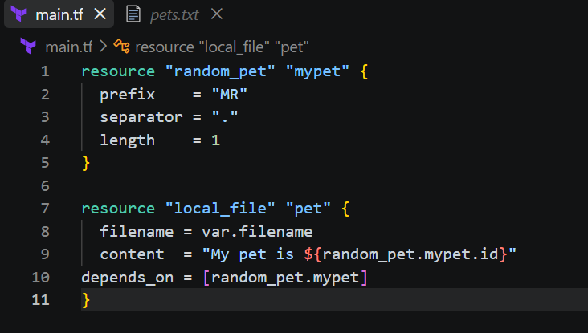
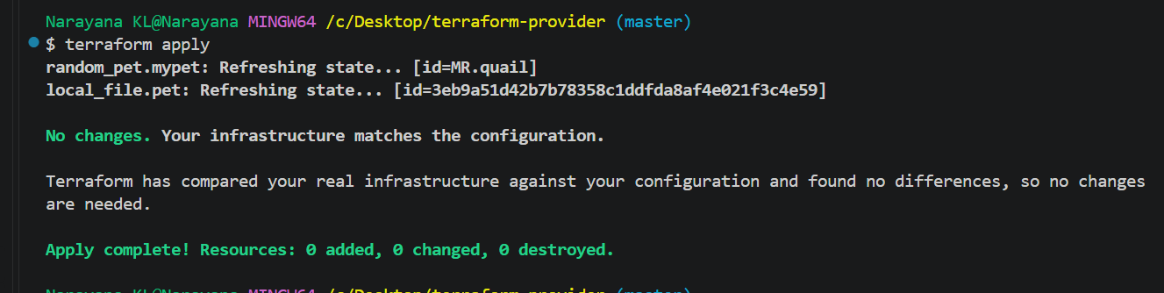
10. Output
Create outputs.tf:
output "pet_name" {
value = random_pet.mypet.id
}
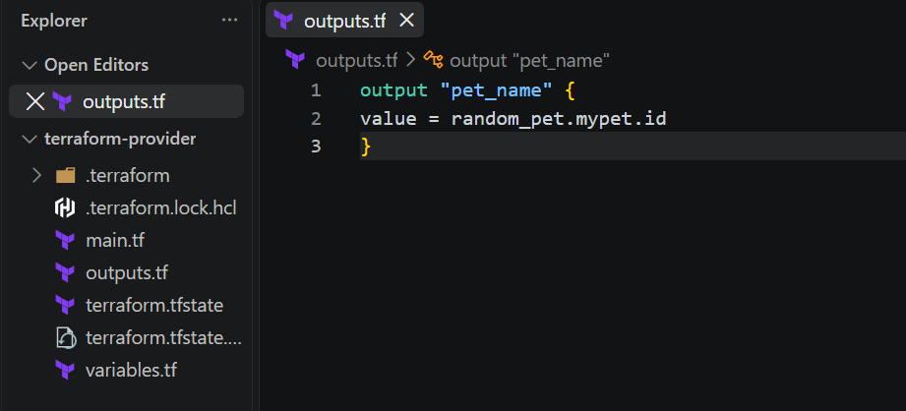
Run Terraform
terraform fmt
terraform validate
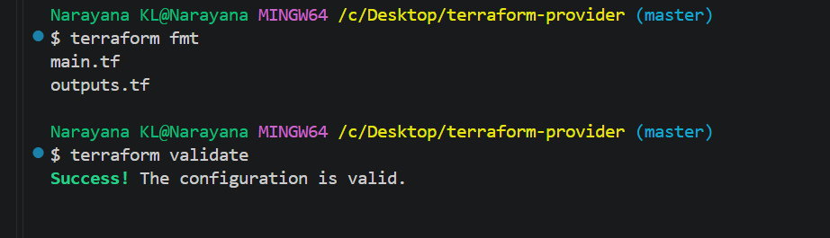
terraform plan
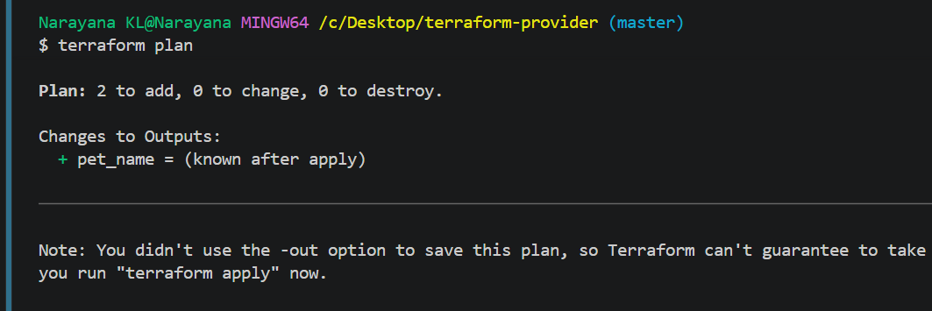
terraform apply
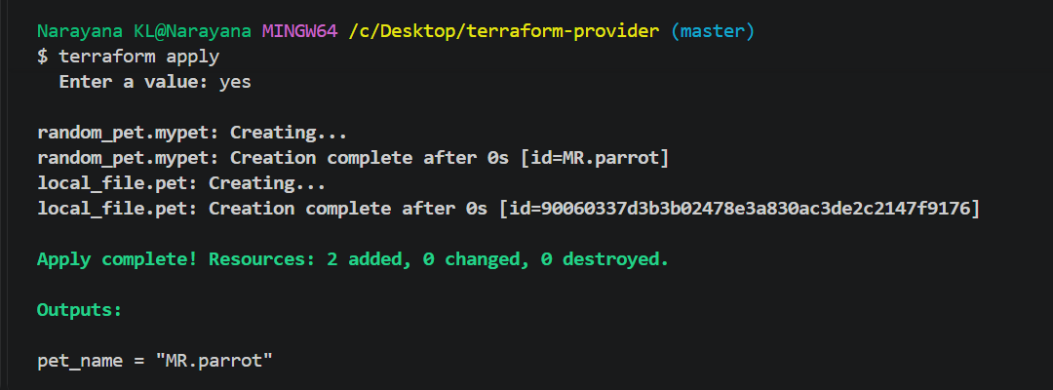
terraform output
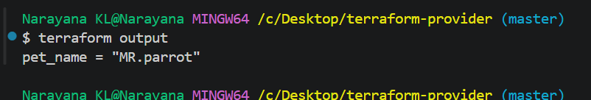
11. State
terraform state list
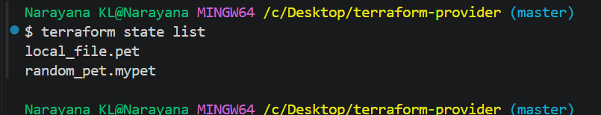
terraform state show local_file.pet
terraform show
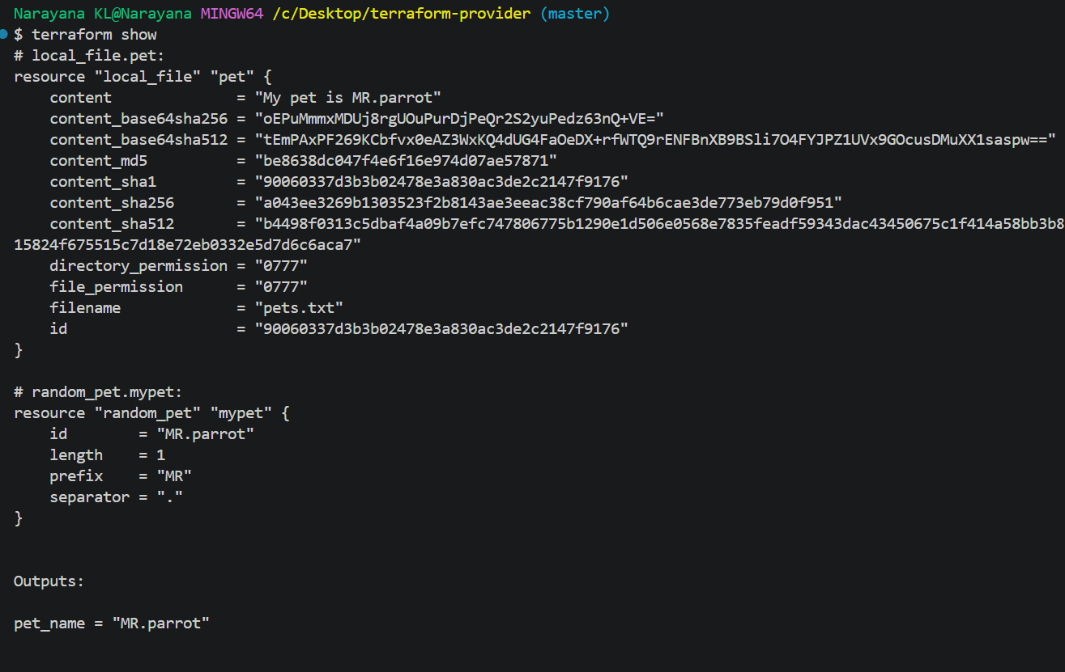
12. Lifecycle
Step 1: Update main.tf
For practice, use:
resource "local_file" "pet" {
filename = var.filename
content = "My pet is ${random_pet.mypet.id}"
lifecycle {
create_before_destroy = true
}
}
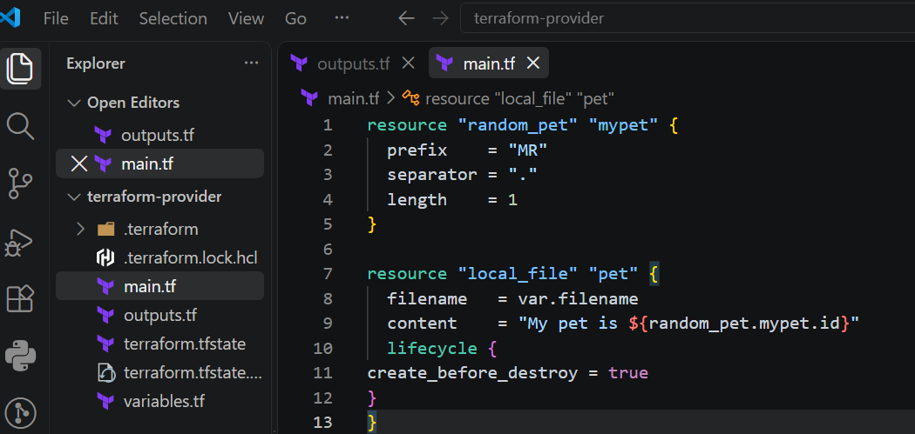
Step 2: Run
terraform fmt
terraform validate
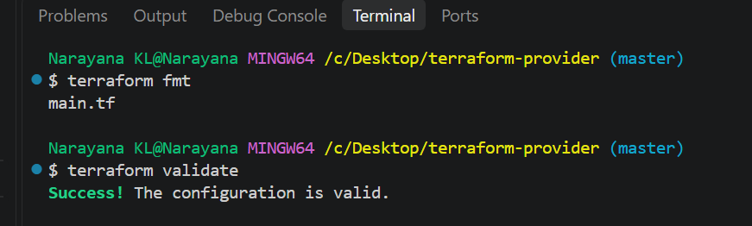
terraform plan
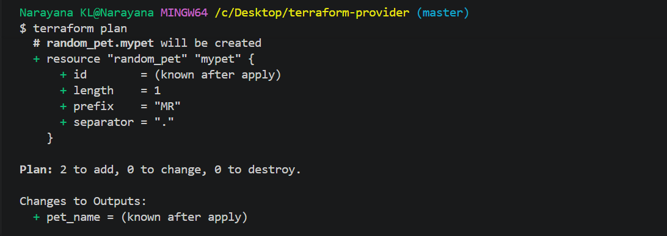
terraform apply
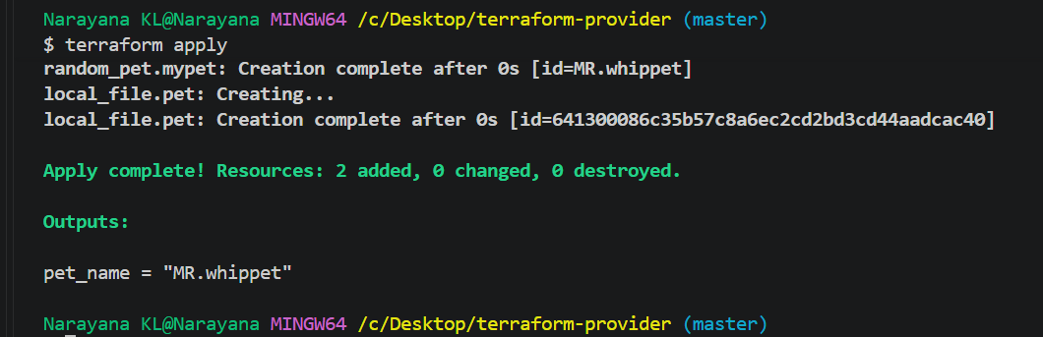
15. For_each
for_each = toset(var.filename)
Use: filename = each.value
Final order to practice
Local → Random → Variables → Variable Types → tfvars → Attribute Reference →
Dependencies → Output → State → Lifecycle → Data Source → Count → For_each.
Integrate Terraform in Jenkins using the Terraform plugin.
1. Install Terraform plugin
Go to:
Jenkins → Manage Jenkins → Plugins → Available plugins
Search:
Terraform
Install Terraform plugin.
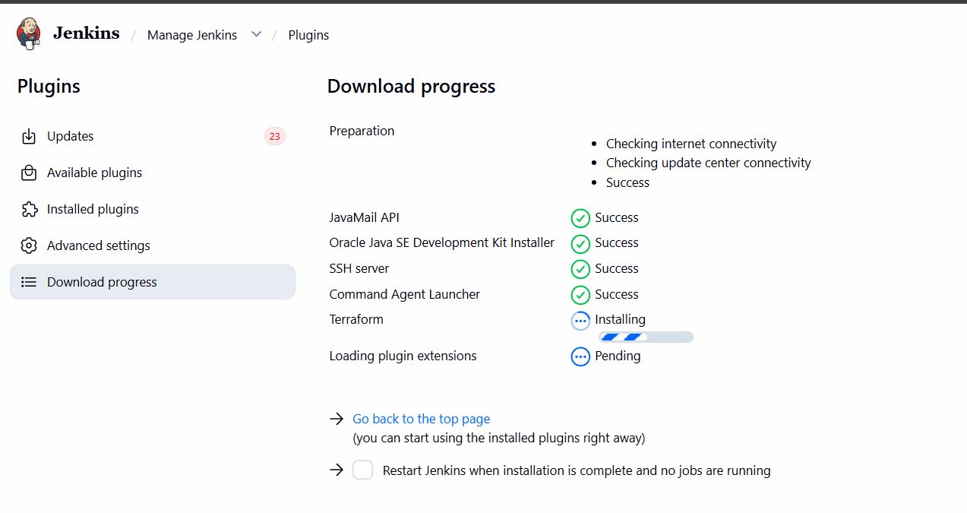
2. Configure Terraform
Go to:
Jenkins → Manage Jenkins → Tools
Find Terraform installations → Add Terraform.
Example:
Name: Terraform
Version: 1.16.1
Save.
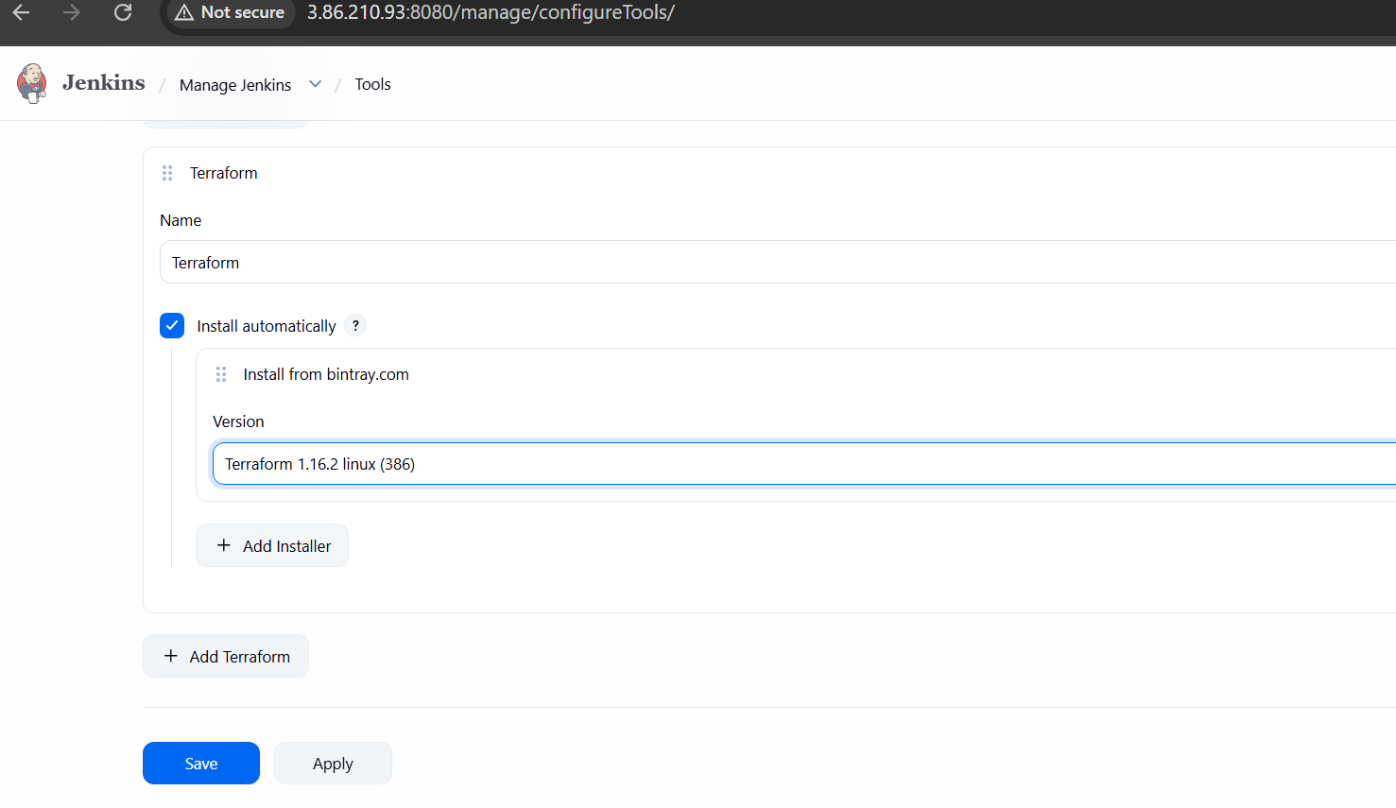
3. Create Jenkins Pipeline
Go to: Jenkins Dashboard → New Item
Select: Pipeline
Give name:
Jenkins-terraform-integrate
Click OK.
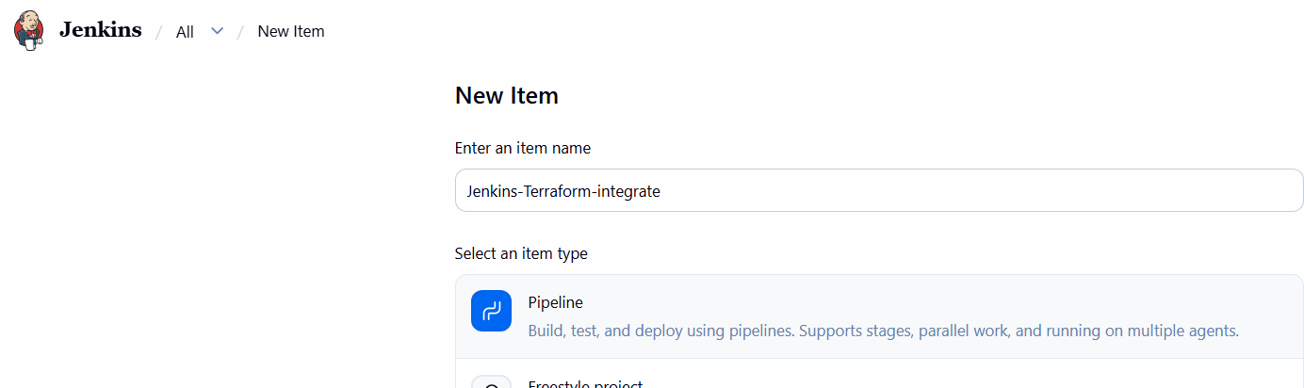
4. Add Pipeline
Go to Pipeline → Definition → Pipeline script.
Use:
pipeline {
agent any

stages {

stage('Checkout') {
steps {
git branch: 'master',
url: 'https://github.com/narayana-28/Terraform-lab.git'
}
}

stage('Terraform Init') {
steps {
dir('terraform-provider') {
sh 'terraform init'
}
}
}

stage('Terraform Validate') {
steps {
dir('terraform-provider') {
sh 'terraform validate'
}
}
}

stage('Terraform Plan') {
steps {
dir('terraform-provider') {
sh 'terraform plan'
}
}
}

stage('Terraform Apply') {
steps {
dir('terraform-provider') {
sh 'terraform apply -auto-approve'
}
}
}

stage('Terraform Output') {
steps {
dir('terraform-provider') {
sh 'terraform output'
}
}
}
}
}
Click Save.
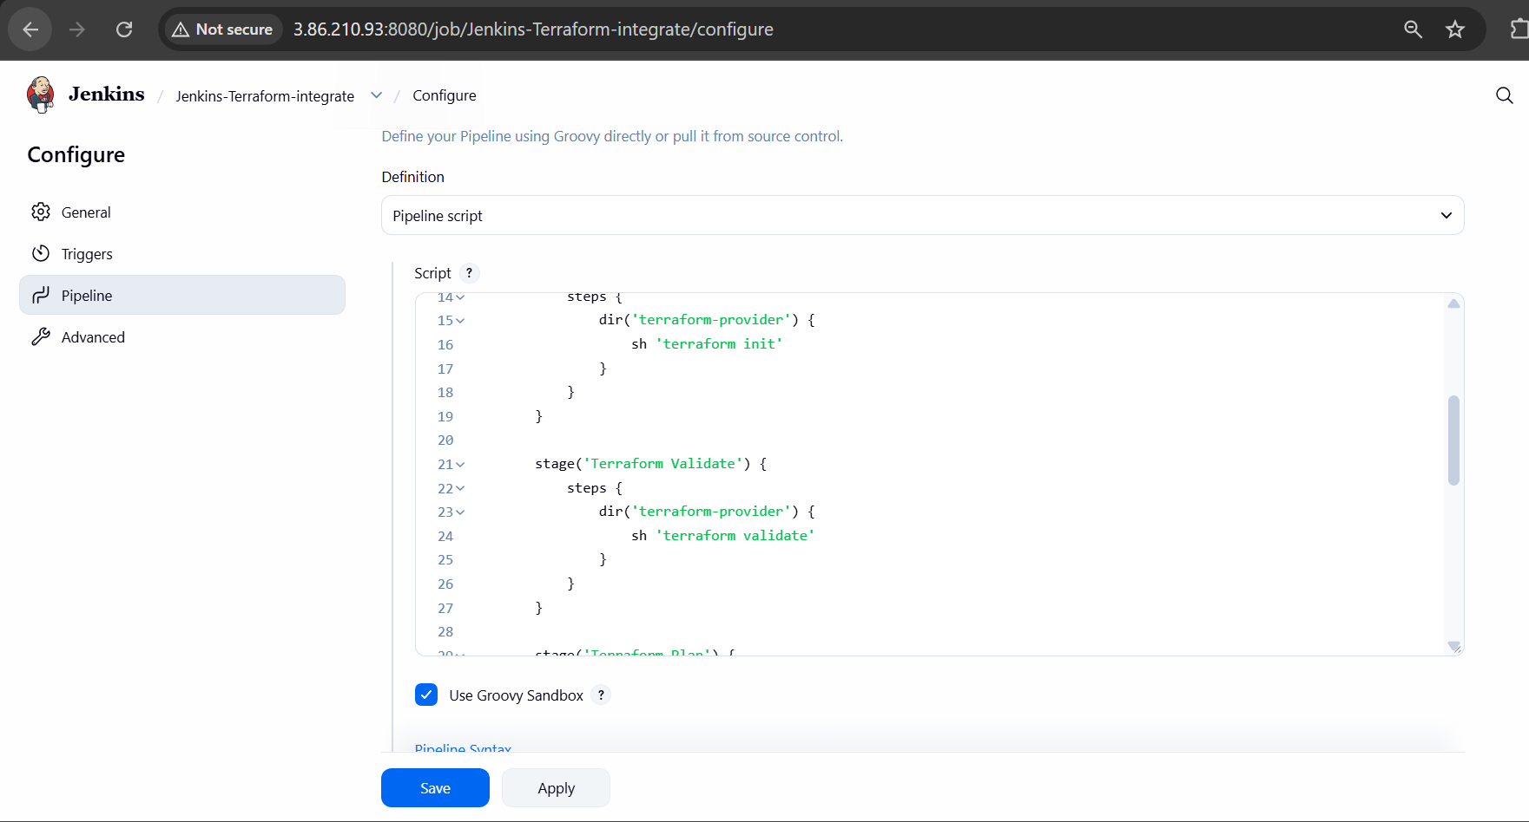
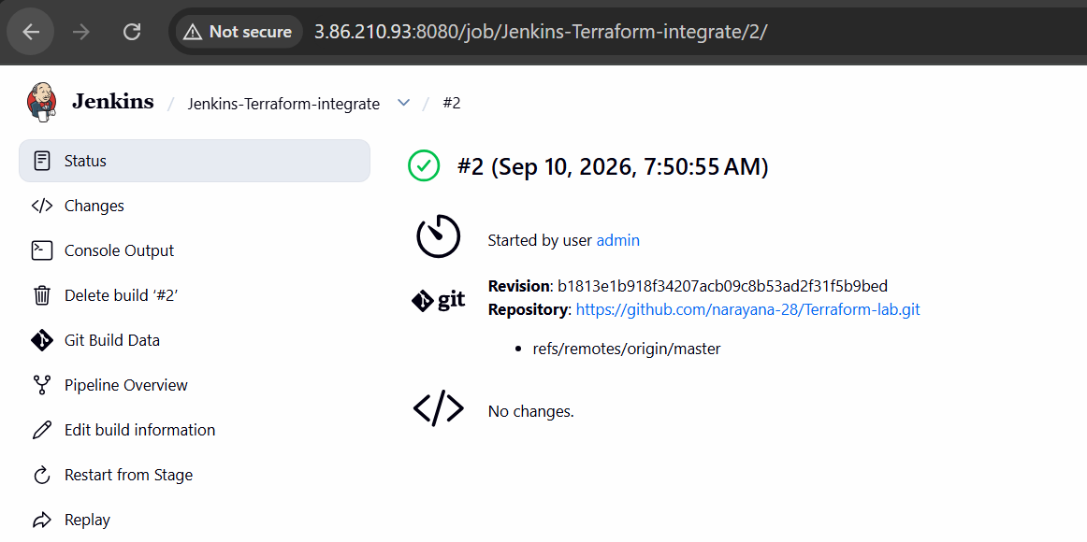
5. Run
Click: Build Now
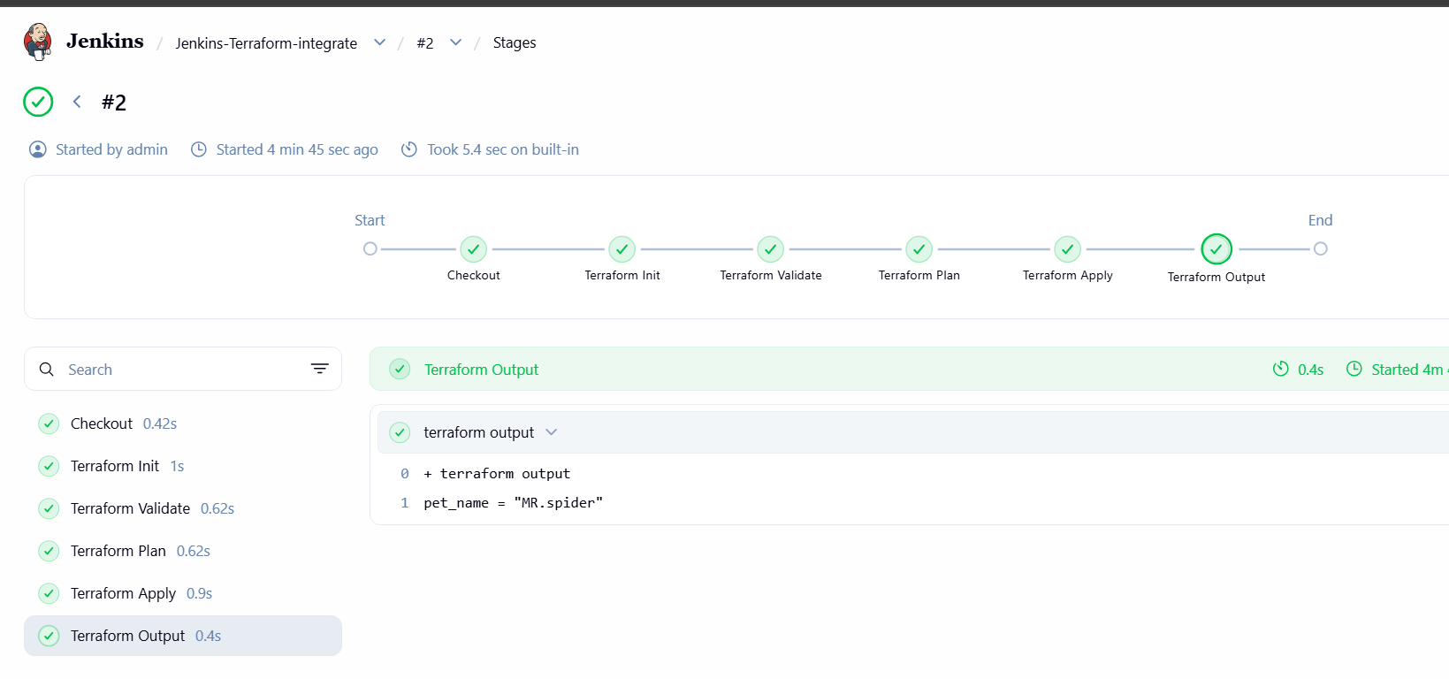
Jenkins will execute:
Jenkins
↓
terraform init
↓
terraform validate
↓
terraform plan
↓
terraform apply

